Table of Contents
Scope of the Database 2
In-Scope Entities 2
Entity Relationship Diagram (ERD) 3
Data Dictionary 6
Normalisation 12
Purpose of Normalisation 12
Justification of Entities in 3rd Normal Form 12
How Normalization is Used to Create Well-Structured Tables 20
Addressing Anomalies with Normalisation 20

Scope of the Database
The database is intended to support the full contribution lifecycle, beginning with student account creation and contribution submission, continuing through review and commenting by marketing coordinators, and ending with the selection and association of approved contributions with magazines for publication.
At the same time, it supports administrative tasks such as managing academic years, monitoring student information, and controlling the relationship between users, faculties, and publication structures.
Overall, the scope of the database is focused on providing a structured, reliable, and connected data environment for the Enterprise Web System so that all major platform activities can be carried out accurately and efficiently.

In-Scope Entities
The in-scope entities for the Enterprise Web System database are:
1. Roles
2. Users
3. Students
4. Faculties
5. Academic Years
6. Contributions
7. Comments
8. Magazines

Junction Tables
9. User-Faculty
10. Student-Academic-Years
11. Academic-Year-Magazines

Entity Relationship Diagram (ERD)
An Entity Relationship Diagram (ERD) is a visual representation of the entities, attributes, and relationships within a database system. It helps database developers, system designers, and other stakeholders understand how data is structured, how different entities are connected, and how primary keys and foreign keys are used to maintain data integrity.
The ERD for this website is designed to represent the main data structure required to support user management, student records, faculty organization, academic year management, contribution submission, review comments, and magazine publication.

It includes 11 entities:
1. Roles,
2. Users,
3. Students,
4. Faculties,
5. Academic Years,
6. Contributions,
7. Comments,
8. Magazines,
9. User-Faculty,
10. Student-Academic-Years, and
11. Academic-Year-Magazines.

The diagram shows the relationships between these entities together with their cardinalities, as well as the primary keys (PK) and foreign keys (FK) that connect them.

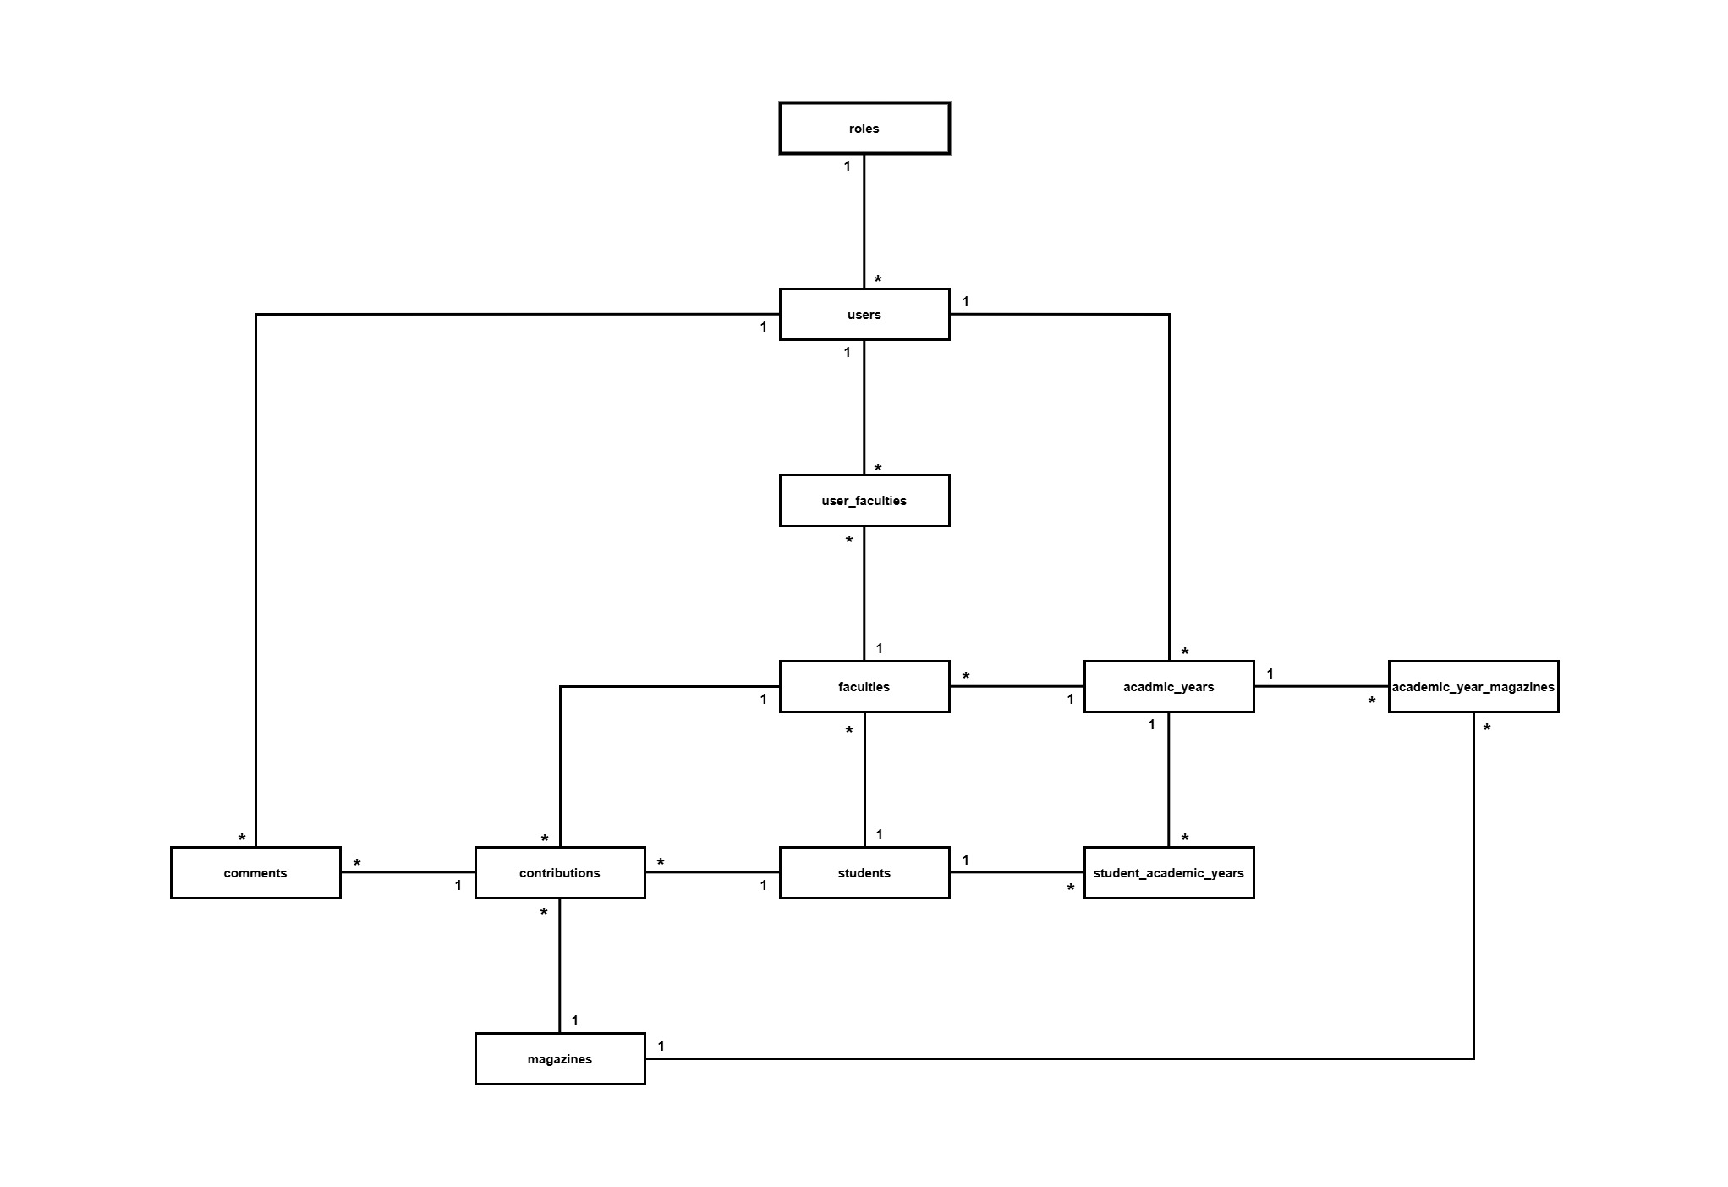
FIG: Entity Relationship Diagram (Vertical) of UniMag Website

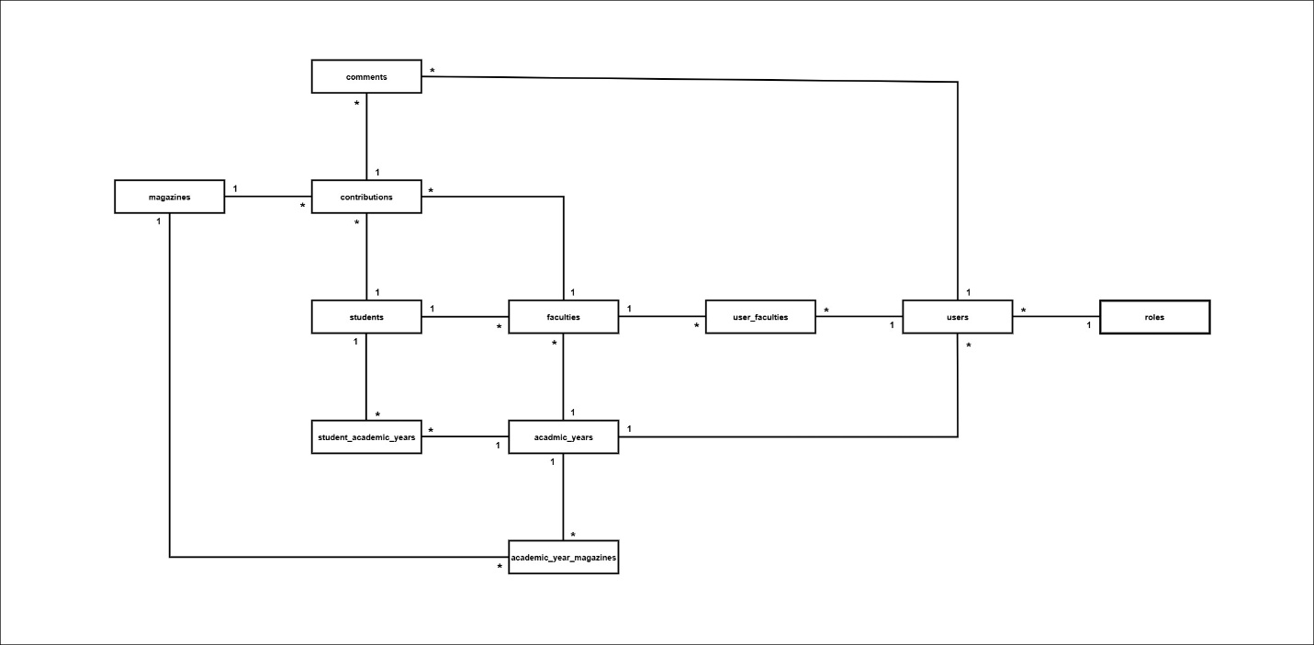
FIG: Entity Relationship Diagram (Horizontal) of UniMag Website

The ERD was created to provide a clear overview of how the database supports the operational workflow of the Enterprise Web System. It illustrates the flow of data from user and student records to contribution submission, review, and final publication within the academic structure of the platform.

Data Dictionary

1. Roles
Entity Name: Roles
Primary Key: id
Foreign Key: -
Attributes | Date Type | Field Size | Key | Description
id | INT | – | PK | Unique identification number for each role.
role | VARCHAR | 255 | – | Name of the role assigned within the system, such as Admin, Student, Marketing Coordinator, Marketing Manager, or Guest.

2. Users
Entity Name: Users
Primary Key: id
Foreign Key: role_id
Attributes | Date Type | Field Size | Key | Description
id | INT | – | PK | Unique identification number for each user.
name | VARCHAR | 255 | – | Full name of the user.
useremail | VARCHAR | 255 | – | Email address used by the user for login and communication.
password | VARCHAR | 255 | – | Encrypted password of the user account.
browser | VARCHAR | 255 | – | Browser information recorded for the user.
role_id | INT | – | FK | References Roles(id) to identify the role assigned to the user.

3. Students
Entity Name: Students
Primary Key: id
Foreign Key: faculty_id
Attributes | Date Type | Field Size | Key | Description
id | INT | – | PK | Unique identification number for each student.
name | VARCHAR | 255 | – | Full name of the student.
email | VARCHAR | 255 | – | Email address used by the student for login and communication.
password | VARCHAR | 255 | – | Encrypted password of the student account.
status | VARCHAR | 255 | – | Current account status of the student, such as active or inactive.
browser | VARCHAR | 255 | – | Browser information recorded for the student.
faculty_id | INT | – | FK | References Faculties(id) to identify the faculty assigned to the student.

4. Faculties
Entity Name: Faculties
Primary Key: id
Foreign Key: user_id, academic_year_id
Attributes | Date Type | Field Size | Key | Description
id | INT | – | PK | Unique identification number for each faculty.
name | VARCHAR | 255 | – | Name of the faculty, such as Medicine, Computing, or Business.
user_id | INT | – | FK | References Users(id) to identify the user associated with the faculty.
academic_year_id | INT | – | – | Identifies the academic year related to the faculty record.

5. Academic Years
Entity Name: Academic Years
Primary Key: id
Foreign Key: user_id
Attributes | Date Type | Field Size | Key | Description
id | INT | – | PK | Unique identification number for each academic year.
title | VARCHAR | 255 | – | Title of the academic year, such as 2026–2027.
start_date | DATE | – | – | Starting date of the academic year.
end_date | DATE | – | – | Ending date of the academic year.
user_id | INT | – | FK | References Users(id) to identify the user who created or manages the academic year.

6. Contributions
Entity Name: Contributions
Primary Key: id
Foreign Key: student_id, faculty_id, magazine_id
Attributes | Date Type | Field Size | Key | Description
id | INT | – | PK | Unique identification number for each contribution.
document_path | VARCHAR | 255 | – | File path of the uploaded Word document.
image_path | VARCHAR | 255 | – | File path of the uploaded image.
title | VARCHAR | 255 | – | Title of the contribution.
description | TEXT | – | – | Description or summary of the contribution.
status | VARCHAR | 255 | – | Current status of the contribution, such as submitted, approved, or needs changes.
submission_date | DATE | – | – | Date on which the contribution was submitted.
student_id | INT | – | FK | References Students(id) to identify the student who submitted the contribution.
faculty_id | INT | – | FK | References Faculties(id) to identify the faculty related to the contribution.
magazine_id | INT | – | FK | References Magazines(id) to identify the magazine associated with the contribution.

7. Comments
Entity Name: Comments
Primary Key: id
Foreign Key: user_id
Attributes | Date Type | Field Size | Key | Description
id | INT | – | PK | Unique identification number for each comment.
comment | TEXT | – | – | Review comment or feedback added to a contribution.
comment_date | DATETIME | – | – | Date and time when the comment was added.
contribution_id | INT | – | FK | References Contributions(id) to identify the contribution being commented on.
user_id | INT | – | FK | References Users(id) to identify the user who wrote the comment.

8. Magazines
Entity Name: Magazines
Primary Key: id
Foreign Key: academic_year_id
Attributes | Date Type | Field Size | Key | Description
id | INT | – | PK | Unique identification number for each magazine.
title | VARCHAR | 255 | – | Title of the magazine publication.
publication_date | DATE | – | – | Date on which the magazine is published.
magazine_path | VARCHAR | 255 | – | File path of the magazine document or publication file.
closure_date | DATE | – | – | Deadline date for initial contribution submission.
final_closure_date | DATE | – | – | Final date after which contributions can no longer be edited or resubmitted.
academic_year_id | INT | – | FK | References Academic Years(id) to identify the academic year linked to the magazine.

9. User-Faculty
Entity Name: User-Faculty
Primary Key: id
Foreign Key: user_id, faculty_id
Attributes | Date Type | Field Size | Key | Description
id | INT | – | PK | Unique identification number for each user-faculty relationship record.
user_id | INT | – | FK | References Users(id) to identify the user linked to a faculty.
faculty_id | INT | – | FK | References Faculties(id) to identify the faculty linked to a user.

10. Student-Academic-Years
Entity Name: Student-Academic-Years
Primary Key: id
Foreign Key: student_id, academic_year_id
Attributes | Date Type | Field Size | Key | Description
id | INT | – | PK | Unique identification number for each student-academic-year relationship record.
student_id | INT | – | FK | References Students(id) to identify the student linked to an academic year.
academic_year_id | INT | – | FK | References Academic Years(id) to identify the academic year linked to a student.

11. Academic-Year-Magazines
Entity Name: Academic-Year-Magazines
Primary Key: id
Foreign Key: academic_year_id, magazine_id
Attributes | Date Type | Field Size | Key | Description
id | INT | – | PK | Unique identification number for each academic-year-magazine relationship record.
academic_year_id | INT | – | FK | References Academic Years(id) to identify the academic year linked to a magazine.
magazine_id | INT | – | FK | References Magazines(id) to identify the magazine linked to an academic year.

Normalisation

Purpose of Normalisation
Normalization is the process of structuring and managing data relationships to minimize redundancy in a relational table by splitting large database tables into smaller tables and creating relationships between them.
It helps remove redundant data and makes it easier to insert, update, and delete table fields.
Normalization also simplifies data management, leading to data consistency and enhanced speed and performance of the overall database system.

Justification of Entities in 3rd Normal Form
To justify why each entity is in Third Normal Form (3NF), the following conditions must be met:
First Normal Form (1NF): The table must have a primary key, and all attributes must contain atomic values with unique names and no repeating groups or arrays.
Second Normal Form (2NF): The table must be in 1NF, and all non-key attributes must eliminate partial dependencies, ensuring they are fully dependent on the primary key.
Third Normal Form (3NF): This level of normalization builds on 2NF, requiring all non-key attributes to be independent of each other by removing transitive dependencies.

1. User and Faculty Management System

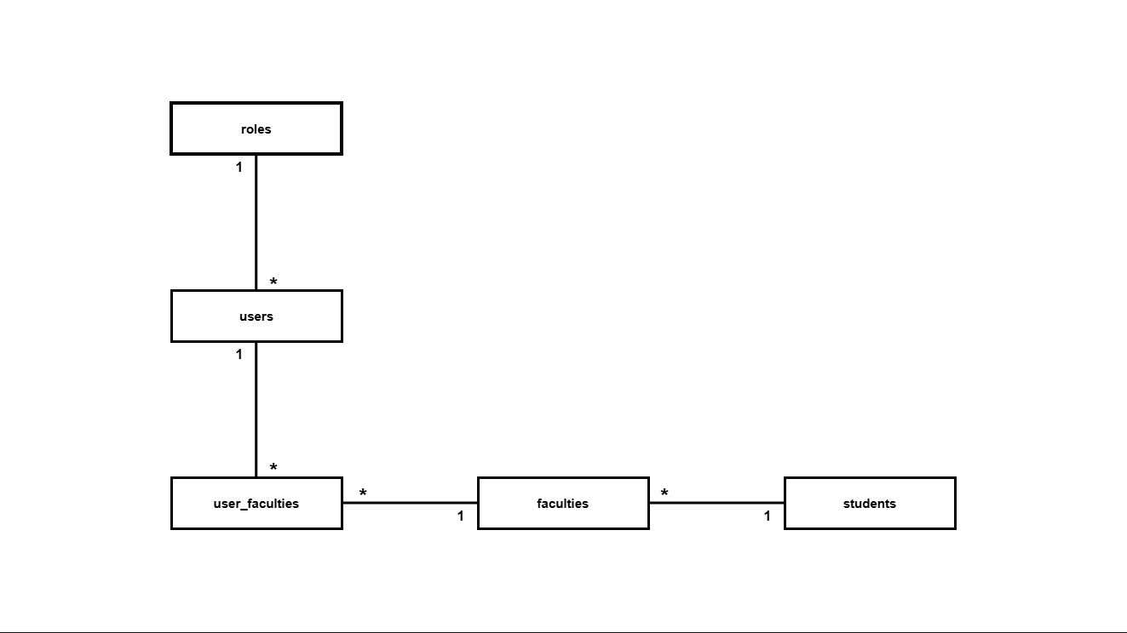
FIG: UniMag’s Wesbite User and Faculty Management System

UNF | Level | 1NF | 2NF | 3NF | Entity
RoleID  RoleName  UserID  UserName  UserEmail  Password  Browser  FacultyID  FacultyName  StudentID  StudentName  StudentEmail  StudentPassword  StudentStatus  StudentBrowser | 1  1  1  1  1  1  1  2  2  2  2  2  2  2  2 | RoleID (PK)  RoleName  UserID (PK)  UserName  UserEmail  Password  Browser  RoleID (FK)  FacultyID  StudentID (PK)  StudentName  StudentEmail  StudentPassword  StudentStatus  StudentBrowser  FacultyID (FK) | RoleID (PK)  RoleName  UserID (PK)  UserName  UserEmail  Password  Browser  RoleID (FK)  FacultyID (PK)  FacultyName  StudentID (PK)  StudentName  StudentEmail  StudentPassword  StudentStatus  StudentBrowser  FacultyID (FK)  UserFacultyID (PK)  UserID (FK)  FacultyID (FK) | id (PK)  role  id (PK)  name  useremail  password  browser  role_id (FK)  id (PK)  name  id (PK)  name  email  password  status  browser  faculty_id (FK)  id (PK)  user_id (FK)  faculty_id (FK) | Roles  Users  Faculties  Students  user_faculties

This normalization process shows how the User and Faculty Management System of the Enterprise Web System is structured from unnormalized data into Third Normal Form.
In the beginning, role, user, faculty, and student data are combined in a single unstructured form, which causes redundancy and repeated values.

Through normalization, the data is divided into separate entities such as roles, users, faculties, students, and user_faculties.
This reduces duplication, removes dependency problems, and ensures that each table stores only the data related to its own purpose.

2. Academic Year and Magazine System

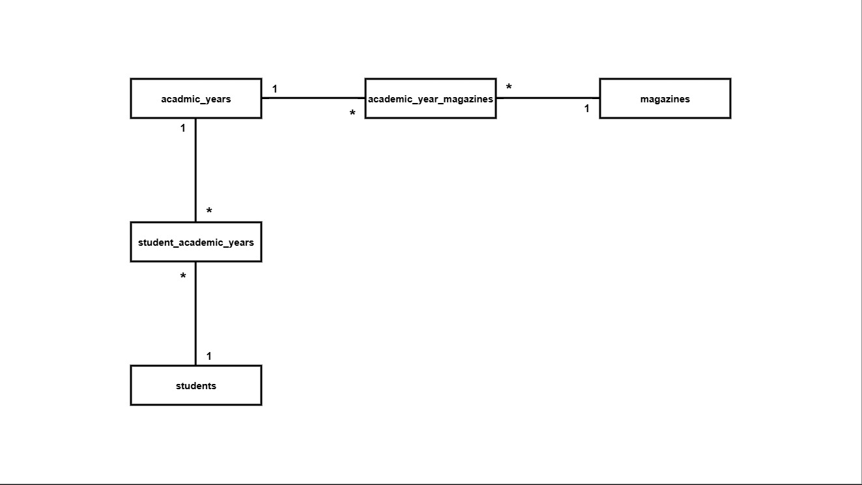
FIG: UniMag’s Website Academic Year and Magazine System
UNF | Level | 1NF | 2NF | 3NF | Entity
AcademicYearID  AcademicYearTitle  StartDate  EndDate  UserID  StudentID  StudentName  StudentEmail  StudentPassword  StudentStatus  StudentBrowser  MagazineID  MagazineTitle  PublicationDate  MagazinePath  ClosureDate  FinalClosureDate | 1  1  1  1  1  2  2  2  2  2  2  2  2  2  2  2  2 | AcademicYearID (PK)  AcademicYearTitle  StartDate  EndDate  UserID (FK)  StudentID  StudentName  StudentEmail  StudentPassword  StudentStatus  StudentBrowser  AcademicYearID (FK)  MagazineID  MagazineTitle  PublicationDate  MagazinePath  ClosureDate  FinalClosureDate  AcademicYearID (FK) | AcademicYearID (PK)  AcademicYearTitle  StartDate  EndDate  UserID (FK)  StudentID (PK)  StudentName  StudentEmail  StudentPassword  StudentStatus  StudentBrowser  MagazineID (PK)  MagazineTitle  PublicationDate  MagazinePath  ClosureDate  FinalClosureDate  AcademicYearID (FK)  StudentAcademicYearID (PK)  StudentID (FK)  AcademicYearID (FK)  AcademicYearMagazineID (PK)  AcademicYearID (FK)  MagazineID (FK) | id (PK)  title  start_date  end_date  user_id (FK)  id (PK)  name  email  password  status  browser  faculty_id (FK)  id (PK)  title  publication_date  magazine_path  closure_date  final_closure_date  academic_year_id (FK)  id (PK)  student_id (FK)  academic_year_id (FK)  id (PK)  academic_year_id (FK)  magazine_id (FK) | Academic_Years  Students  Magazines  student_academic_  years  academic_year_  magazines

This normalization process shows how the Academic Year and Magazine System of the Enterprise Web System is structured from unnormalized data into Third Normal Form.
In the beginning, academic year, student, and magazine data are combined in one unstructured form, which causes repeated values and data redundancy.
Through normalization, the data is divided into separate entities such as academic_years, students, magazines, student_academic_years, and academic_year_magazines.
This reduces duplication, improves consistency, and ensures that each table stores only the data related to its own purpose.
3. Contribution and Review System

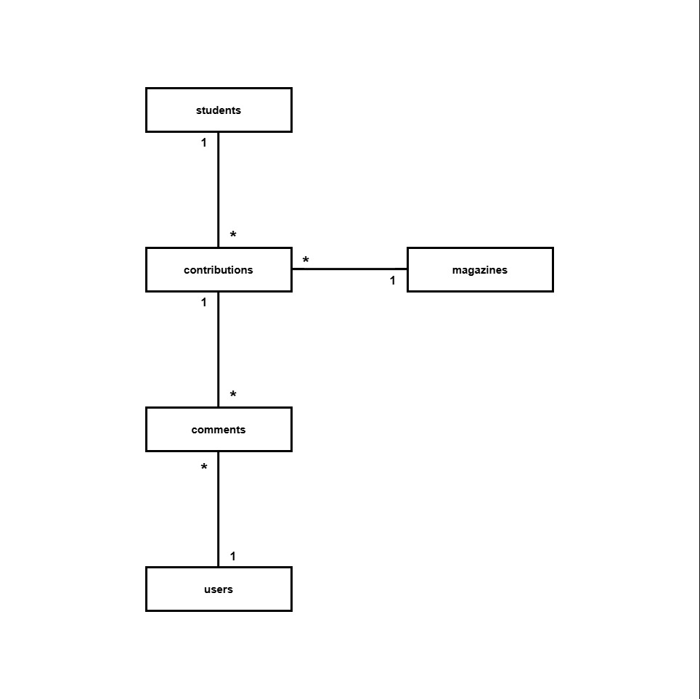
FIG: UniMag’s Website Contribution and Review System

UNF | Level | 1NF | 2NF | 3NF | Entity
StudentID  StudentName  StudentEmail  StudentPassword  StudentStatus  StudentBrowser  ContributionID  DocumentPath  ImagePath  ContributionTitle  Description  ContributionStatus  SubmissionDate  MagazineID  MagazineTitle  PublicationDate  MagazinePath  ClosureDate  FinalClosureDate  CommentID  Comment  CommentDate  UserID  UserName  UserEmail  UserPassword  UserBrowser | 1  1  1  1  1  1  2  2  2  2  2  2  2  2  2  2  2  2  2  3  3  3  3  3  3  3  3 | StudentID (PK)  StudentName  StudentEmail  StudentPassword  StudentStatus  StudentBrowser  ContributionID (PK)  DocumentPath  ImagePath  ContributionTitle  Description  ContributionStatus  SubmissionDate  StudentID (FK)  MagazineID (FK)  MagazineID  MagazineTitle  PublicationDate  MagazinePath  ClosureDate  FinalClosureDate  CommentID  Comment  CommentDate  ContributionID (FK)  UserID (FK)  UserName  UserEmail  UserPassword  UserBrowser | StudentID (PK)  StudentName  StudentEmail  StudentPassword  StudentStatus  StudentBrowser  ContributionID (PK)  DocumentPath  ImagePath  ContributionTitle  Description  ContributionStatus  SubmissionDate  StudentID (FK)  MagazineID (FK)  MagazineID (PK)  MagazineTitle  PublicationDate  MagazinePath  ClosureDate  FinalClosureDate  CommentID (PK)  Comment  CommentDate  ContributionID (FK)  UserID (FK)  UserID (PK)  UserName  UserEmail  UserPassword  UserBrowser | id (PK)  name  email  password  status  browser  faculty_id (FK)  id (PK)  document_path  image_path  title  description  status  submission_date  student_id (FK)  faculty_id (FK)  magazine_id (FK)  id (PK)  title  publication_date  magazine_path  closure_date  final_closure_date  academic_year_id (FK)  id (PK)  comment  comment_date  contribution_id (FK)  user_id (FK)  id (PK)  name  useremail  password  browser  role_id (FK) | Students  Contributions  Magazines  Comments  Users

This normalization process shows how the Contribution and Review System of the Enterprise Web System is structured from unnormalized data into Third Normal Form.
At the beginning, student, contribution, magazine, comment, and user data are combined in one unstructured form, which causes repeated values and unnecessary redundancy.

Through normalization, the data is divided into separate entities such as students, contributions, magazines, comments, and users.
This reduces duplication, improves consistency, and ensures that each table stores only the data related to its own purpose.

How Normalization is Used to Create Well-Structured Tables
Each system operates with a complex database. Normalization breaks down the database into smaller tables, ensuring each table contains only relevant information. This reduces the need for complicated relationship joins.
After the database is divided into smaller tables, normalization links these tables through unique identifiers (Foreign Keys), ensuring the data remains accurate and consistent.
By using normalization, data duplication is avoided, and query executions such as insert, update, and delete are performed faster on smaller tables. It also ensures that data remains consistent and accurate.

Addressing Anomalies with Normalisation
Normalization helps the Enterprise Web System avoid common data anomalies by storing data in separate but related tables.

Insert anomaly happens when new data cannot be added without adding unrelated data. For example, if faculty details were stored inside the Students or Users table, a new faculty could not be added unless a student or user record already existed. By storing faculties in a separate table, new faculty records can be added independently.
Update anomaly happens when the same data is repeated in many rows. For example, if magazine details were stored in every contribution record, changing one deadline would require updating multiple rows. This could cause inconsistent data. By storing magazine details in the Magazines table, the update only needs to happen once.
Delete anomaly happens when deleting one record removes other important data. For example, if comments were stored inside the Contributions table, deleting a contribution could also remove review information. By storing comments and academic year relationships in separate tables, important data is protected.

Overall, normalization improves accuracy, consistency, and data management by reducing insert, update, and delete anomalies.

